**Activity based**

**Project Report on**

**Computer Network Laboratory**

**Project Module IV**

**Submitted to Vishwakarma University, Pune**

**Under the Initiative of**

**Contemporary Curriculum, Pedagogy, and Practice (C2P2)**

**By**

**Student Name**

**SRN No : 111111111**

**Roll No : 09**

**Div : B**

**Third Year Engineering**

**Department of Computer Engineering**

**Faculty of Science and Technology**

**Academic Year**

**2024-2025**

**Design and develop a LAN & WAN network and implement static routing using router Commands**

**Project Statement:**

Implement Static Routing for following network.

Select Class A IP addresses.

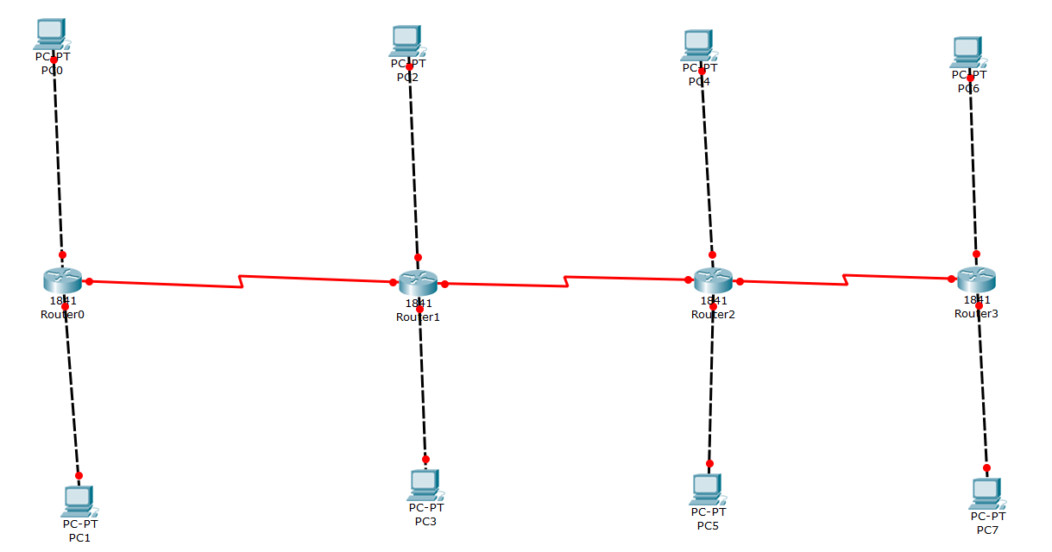

**Problem Description:**

1. Develop a LAN and WAN network for above mentioned diagram.
2. Implement Static routing.
3. Add screenshot of router commands used in each router.
4. Show successful communication in between different Network through screenshot.

**Conclusion :**

<<Write Conclusion in your own words. Write about what you learn from assignment>>

*Important Instruction

Word document Formatting:

Font: Times New Roman

Font size: for text 12 and for title : 14

Line spacing : 1.5

Give figure number with name

Give table no with name